
FTTH SAT Optical Node With PWDM

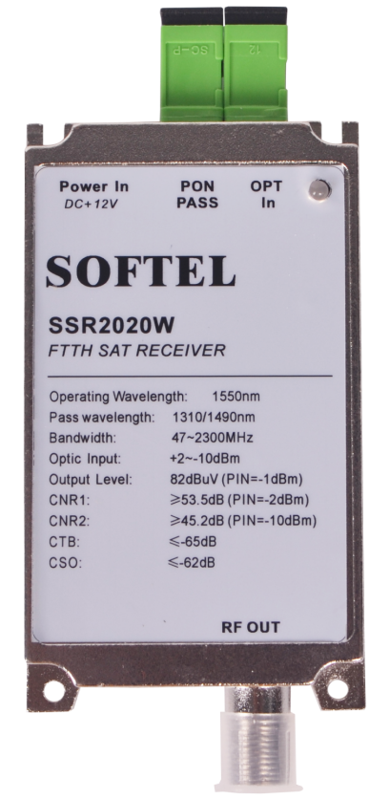
SSR2020W

Features:
1.Designed For FTTH (Fiber to the Home Network)
2.Excellent Linearity and flatness
3.Frequency range 40-2300MHz For CATV And PON Pass
4.Voltage supply: +5V(DC)
5.Optical Connector: IN SC/APC, OUT SC/UPC
6.Aluminum Profiles housing,excellent heat dissipation
7.Smaller size and easier install
8.Red-LED Power Indication
9.Green-LED Optical Power Indication(Optical power >-13dBm)

Specifications
Number Item |  | Unit | Description | Remark
Customer Interface
1 | RF Connector |  | 75Ω"F" connector
2 | Optical Connector |  | SC/APC
3 | DC Supply |  | DC Adapter
Optical Parameter
4 | Input Optical Power | dBm | -20 ~ +2
5 | Optical Return Loss | dB | >45
6 | Optical Receiver Wavelength | nm | 1550nm
7 | Optical Fiber Type |  | Single Mode
8 | PON Pass | nm | 1310/1490nm
RF Parameter
9 | Frequency Range | MHz | 40-860 960-2300MHz
10 | Flatness | dB | ±1
11 | RF Return Loss | dB | -14
12 | Output Level | dBuV | 83 | @0dBm
13 | Output Impedance | Ω | 75
14 | C/N | dBc | 52 | -1dBm input power
Other Parameter
15 | Power Input Voltage | VDC | +5V
16 | Power Consumption | W | <5.0
17 | Dimensions | mm | 60*60*24
18 | Net weight | KG | 0.108

